Name:
Date:
Miles Davis- “Birth of the Cool”

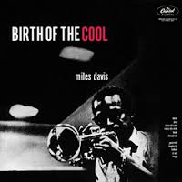
General Questions

1. What year was the album released?

2 Where was this recorded? Who was the arranger?

3. How many musicians were in the band?

4 What were some instruments used in the band?

Notes:

Name:
Date:
“Birth of the Cool” listening Analysis

“Move”

Describe in your own words, Use musical terminology:

Style:

Tempo:

Melody (who plays):

Harmony/ Counterpoint:

Additional notes:

“Moon dreams”

Describe in your own words

Style:

Tempo:

Melody (who plays):

Harmony/ Counterpoint:

Additional notes:

