Lesson Plan

Name: Larry Shea Date: 11/21/15
Grade/Class: 3rd Grade

1. Measurable Objective(s): (Measurable learning objectives use action verbs to describe what you want the students to be able to do by the end of the class, course, or unit)

- As a result of this lesson, students will be able to compose a four measure rhythm using a mix of half, quarter, and eighth notes.

2. Required Prior Knowledge and Skills: (What must students know to be successful)
- Know Half, quarter, and eighth note rhythms
- Know quarter note rest
- Know 4/4 time signature
- Know the song “Twinkle-Twinkle”

3. Review Needed: (What needs to be reviewed to reinforce prior learning related to this lesson)
- Counting, playing, and performing half, quarter, and eighth note rhythms in 4/4 time signature

4. Materials, Repertoire, Equipment needed:
1. Expo markers and eraser
2. Drums
3. Popsicle sticks
4. Notation paper for rhythms (Template set up by teacher)
5. Pencils
5. Agenda: (list items to be taught and post – use large paper and dark marker if white board is not available)
1. Brief opening/review
2. Creating Rhythms with popsicle sticks
3. Group rhythm Composition
4. Group performances
5. Class rhythm composition
6. Assessment
7. Closing/ Wrap-up activity

6. Lesson Sequence (be sure to list time in the pacing section) Pacing
A. Brief Opening: (Teacher posted brief assignment that may be done independently. Brief reading writing, editing, or problem solving activity to ready them for learning – may be a question about the music that will be rehearsed or at the younger levels it may be a learning activity setting up for today’s lesson)  - Gather students to form a circle with drums  “Alright everyone, lets have everyone grab one drum each and come to the center of the room to make a circle”  “Today we’re going to start off by going over and playing some of the rhythms we learned about.”  “Who can tell me how many beats does a half note get? Quarter? Eighth?”  “What syllable do we use for half and quarter notes? Quarter note rest? And what about eighth notes?”  “So I’m going to play a few rhythms for you and say the syllables too. After I go, I want you guys to play and say the syllables back to me.”  Ex)  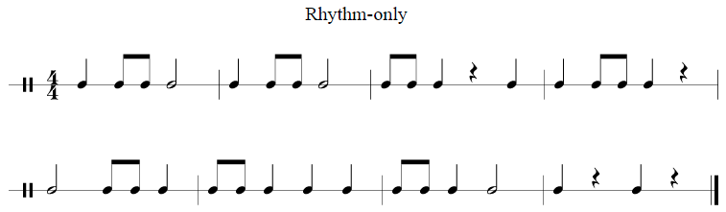  “So now that we played some of these rhythms, lets all put the drums to the side for now. We are going to come back and use these later.” | 3-5 min.
B. Learning Activities: (What learning experiences and instruction will enable students to achieve the desired results – have more learning activities than you need)  1. Using popsicle sticks to create rhythms  - Gather students on the floor and explain how half, quarter, and eighth note rhythms are notated using the board  “Lets have everyone come sit on the floor and make a circle by the board so you can see me.”  “Who remembers and can show me what a half note looks like by coming up to the board? Quarter note? Eighth note? Quarter note rest?”  - Correct and guide as necessary  - Write a simple rhythm of the board, and as a group discuss and come up with a way to create it using popsicle sticks  “We are going to use popsicle sticks today to represent these rhythms like they are notated. Let me show you a rhythm example that we can do together.”  Ex)  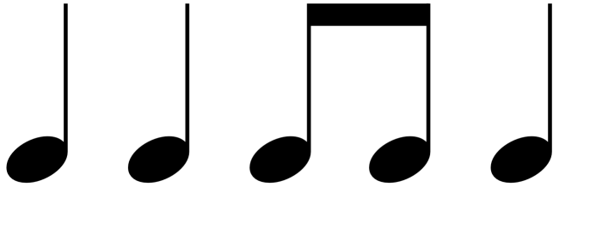  “ What two kinds of notes do we have in this rhythm?”  “How do you think we can use the popsicle sticks to make the quarter notes? Eighth notes?”  “For our quarter notes, we will just use one stick. For eighth, we will make an upside down U with three sticks”.  “Lets clap and say this rhythm together using our syllables”  - Write another rhythm on the board that includes a half note and a quarter rest, and as a group, create it using the popsicle sticks  “Here’s another rhythm”  Ex)  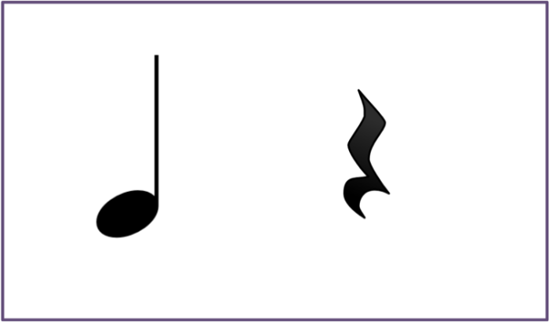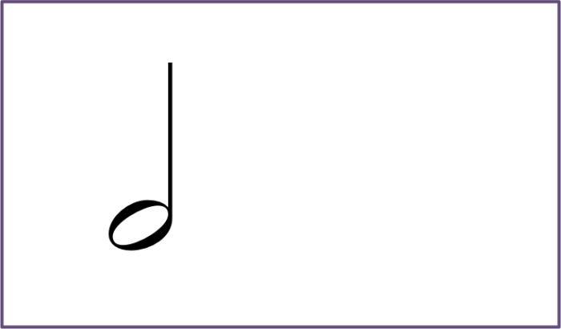  “Who can tell me what kinds of notes we have here? Is there a rest in this one?”  “How do you think we can make a half note using the popsicle sticks? What about a quarter note rest?”  “For half notes, we will put two popsicle sticks right next to each other, and for a quarter note rest, we will leave a small gap”  “Lets clap and say this rhythm using our syllables.”  2. Assign students to small, even groups to create a 4 measure rhythm using popsicle sticks and notation  - Explain the requirements and process for the composition  “ So in your groups that I assigned you to, you guys are going to use the popsicle sticks to create a 4 measure rhythm in 4/4 time.  Here are the requirements  - You must use quarter and eighth notes  - You must have one half note rhythm  - You must have two quarter note rests  “Here’s how I want you guys to do this”  - Create one measure of rhythm at a time with the popsicle sticks  - Clap and say the rhythm using syllables  - Using the piece of notation paper I give you, write the rhythm in each outlined measure using the correct notation we talked about earlier, and write the syllables over each rhythm.  - Do this again until all 4 measures are done  “I’ll be coming to each group to help you guys out, make sure to work together!”  - Give each group a bag of popsicle sticks, a piece of notation paper with 4 outlined measures, and a pencil to create their rhythms  - Let students create there 4 measure rhythm composition  3. Have each group perform their composition with drums for the class  “Ok everyone time is up. I want you to put the popsicle sticks away neatly, and then go grab your drum you used earlier in class.”  “ When I call on your group, I want you to play your four measures of rhythm you created on your drums, and make sure to sing the syllables too.”  (Repeat until all groups go)  4. Select a measure from each groups composition to create a class composition  “ Alright, so I outlined a measure for each group on the white board, and I want each group to select one measure of their composition. One person will come up and write that measure on the board.”  “Make sure to write both your syllables and notes properly.”  - Have the whole class first clap and say the rhythms with their syllables, then have them perform the rhythms on the drums.  “ So now that we have a class composition, lets perform this. We are going to clap and say the syllables of the rhythms first”  “Now lets play the whole thing with our drums” | 1. 5-7 min  2. 10-12 min.  3. 5-7 min.  4. 6-8 min.
C. Assessment: (What evidence will show that the students understand? Describe the assessment used – formal and informal assessments based on learning objectives)  Informal assessment for Activity 2 and 3:  - In these activities, students will be assessed based on how accurately they composed their 4 measure rhythms, used required criteria, and were able to show an understanding of knowing each rhythm they used in their composing and performing skills.  - Assessment would be by the groups assigned in class. Each group would have individuals names charted, and students would receive a check next to their name if they met the standard requirements, or a slash if they didn’t. The teacher will also collect each group’s composition for the next lesson.  Formal Assessment (5-7 minutes):  - For an individual formal assessment, students would each be handed a worksheet (Outlined by teacher) to compose two measures of rhythm. This assessment will be similar to the composition activity and will have requirements for rests and certain rhythms. This assessment is used to see if individual students can be successful composing these rhythms on their own, and will be assessed based on how well they meet the requirements. | 5-7 min.
D. Closing/Wrap-up: (This is a recap of the key learning of the day to check for understanding. Could be a ticket to leave as individuals or group answers)  - Students will sing the song “Twinkle-Twinkle”, and one student will create a one measure rhythm accompaniment for everyone in the class to play while singing the song  “So before we put our drums away, we are going to do an activity to the song “Twinkle-Twinkle”  - Display the song and lyrics for students  “Lets sing along”  - Pick a student and explain how they will compose an accompanying rhythm  “So I need a volunteer who will compose a one measure rhythm for the whole class to play along while singing this song”  “You can use a mix of any of the rhythms we used today in our compositions” “I’ll give you an example”  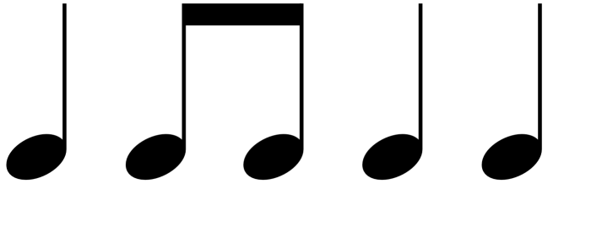  “ Now lets perform the rhythm while singing the song. Who wants to try to make their own for the class?”  (Do for 3 people)  “Lets put away our drums now silently and quickly, and then line up at the door.” | 5-7 min.
E. Assignment: - Students will be asked and encouraged to create their own rhythms with any object outside of class using the rhythms they learned about. Examples of this would be tapping pots and pans at their house, or playing with a basketball on the court. | 40 min.

7. Accommodations: (a. Special Needs, b. ELL etc. )

A student with a Learning Disability has trouble being able to reason and compose rhythms for the composition activity in their group and on their own. To accommodate this student, they will be provided with a page full of teacher examples that they can use as a resource to still create their own rhythms with guidance, and also be placed in a group mixed with students capable of composing well in order for them to still participate in the activity. That way, they will be accommodated enough and be able to help their group to compose their rhythms, and be able to compose their own rhythms for the formal assessment.

8. Teacher Reflection/Self-Evaluation: (a. Reflect on the process and include student responses b. Rethink & Revise - what could you have done differently to improve the outcome of this lesson)

Overall, I felt this lesson was very engaging and successful for student’s rhythm composition abilities. There were some activities like using popsicle sticks and composing 4 measures in groups that seemed very interactive and entertaining for the class. Because of this, students were learning in an engaging way, and were able to show understanding and technicality of the previously learned rhythms by composing on their own. I also felt that there were some weak points in the lesson too. For example, students did not seem very engaged and lost interest when the class composed together. This was due to the fact that there was too much focus on just playing rhythms in the class, and students didn’t get the opportunity to participate in any other concepts like singing or moving. I also felt that when in groups, some students became distracted or started misbehaving when they were not under full class supervision. Next time, I would replace the group composition activity with something else that would be different and engaging for students. That way they would not lose focus and participate in the lesson more. I would also consider better placement of students in groups and supervise them closely to prevent distraction and any other behavioral issues.

9. National Standards: (Creating, Performing, Responding)

Creating:
Imagine
MU:Cr1.1.3a Improvise rhythmic and melodic ideas, and describe connection to specific purpose and context (such as personal and social).
MU:Cr1.1.3b Generate musical ideas (such as rhythms and melodies) within a given tonality and/or meter.
Plan and make
MU:Cr2.1.3a Demonstrate selected musical ideas for a simple improvisation or composition to express intent, and describe connection to a specific purpose and context.
MU:Cr2.1.3b Use standard and/or iconic notation and/or recording technology to document personal rhythmic and melodic musical ideas.
Evaluate
MU:Cr3.1.3a Evaluate, refine, and document revisions to personal musical ideas, applying teacher-provided and collaboratively- developed criteria and feedback.
Present
MU:Cr3.2.3a Present the final version of personal created music to others, and describe connection to expressive intent.
Performing:
Select
MU:Pr4.1.3a Demonstrate and explain how the selection of music to perform is influenced by personal interest, knowledge, purpose, and context.
Analyze
MU:Pr4.2.3a Demonstrate understanding of the structure in music selected for performance.

MU:Pr4.2.3b When analyzing selected music, read and perform rhythmic patterns and melodic phrases using iconic and standard notation.
Rehearse, Evaluate, and Refine
MU:Pr5.1.3a - Apply teacher- provided and collaboratively- developed criteria and feedback to evaluate accuracy of ensemble performances.
Present
MU:Pr6.1.3a Perform music with expression and technical accuracy.
Responding:
Evaluate
MU:Re9.1.3a Evaluate musical works and performances, applying established criteria, and describe appropriateness to the context.
Connecting:
Connect #10
MU:Cn10.0.3a Demonstrate how interests, knowledge, and skills relate to personal choices and intent when creating, performing, and responding to music.
MU:Cr2.1.3a Demonstrate selected musical ideas for a simple improvisation or composition to express intent, and describe connection to a specific purpose and context.
MU:Cr3.2.3a Present the final version of created music for others, and describe connection to expressive intent.
MU:Pr4.1.3a Demonstrate and explain how the selection of music to perform is influenced by personal interest, knowledge, purpose, and context.
MU:Pr4.3.3a Demonstrate and describe how intent is conveyed through expressive qualities (such as dynamics and tempo.
10. State Standards: (Singing, Reading & Notation, Playing Instruments, Improvisation & Composition, Critical Response, Purposes & meaning in the arts, Rose of artists in communities, Concepts of style, stylistic influence & stylistic change, Inventions technologies & the arts, Interdisciplinary connections)

Singing:
- 1.5 Sing in groups, blending vocal timbres, matching dynamic levels, and responding to the cues of a conductor
Reading and Notation:
- 2.1 Demonstrate and respond to: the beat, division of the beat, meter (2/4, 3/4, 4/4), and rhythmic notation, including half, quarter, eighth, and sixteenth notes and rests
- 2.2 Use a system (syllables, numbers, or letters) to read and sing at sight simple pitch notation in the treble clef
- 2.4 Use standard symbols to notate meter, rhythm, pitch, and dynamics in simple patterns performed by the teacher
Playing Instruments:
- 3.4 Echo and perform easy rhythmic, melodic, and chordal patterns accurately and independently on rhythmic, melodic, and harmonic classroom instruments
- 3.5 Perform in groups, blending instrumental timbres, matching dynamic levels, and responding to the cues of a conductor
- 3.6 Perform independent instrumental parts while other students sing or play contrasting parts

Improvisation and Composition:
- 4.2 Improvise and compose simple rhythmic and melodic ostinato accompaniments
- 4.5 Create and arrange short songs and instrumental pieces within teacher- specified guidelines
Critical Response:
- 5.1 Perceive, describe, and respond to basic elements of music, including beat, tempo, rhythm, meter, pitch, melody, texture, dynamics, harmony, and form
- 5.3 Use appropriate terminology in describing music, music notation, music instruments and voices, and music performances
- 5.6 Describe and demonstrate audience skills of listening attentively and responding appropriately in classroom, rehearsal, and performance settings

