Lesson Plan

Name: Larry Shea Date: 11/20/15
Grade/Class: 3rd grade

1. Measurable Objective(s): (Measurable learning objectives use action verbs to describe what you want the students to be able to do by the end of the class, course, or unit)
- As a result of this lesson, students will be able to distinguish eighth note rhythms from quarter and half notes rhythms

2. Required Prior Knowledge and Skills: (What must students know to be successful)
- Play and count quarter and half note rhythms
- Know what quarter and half notes look like in notation
- Understand 4/4 and 2/4 time signatures

3. Review Needed: (What needs to be reviewed to reinforce prior learning related to this lesson)
- Counting and clapping quarter and half note rhythms in 4/4 and 2/4 time

4. Materials, Repertoire, Equipment needed:
- Drums
- Expo markers and eraser
- Copy of the song “Rain, Rain, Go Away”

5. Agenda: (list items to be taught and post – use large paper and dark marker if white board is not available)

1. Brief Opening/ Review
2. Learning eighth notes
3. Teach “Rain, Rain, Go Away”
4. Reviewing rhythms on board / drumming to “Rain, Rain Go Away”
5. Creating and performing rhythm mnemonics
6. Closing/Wrap up activity

6. Lesson Sequence (be sure to list time in the pacing section) Pacing
A. Brief Opening: (Teacher posted brief assignment that may be done independently. Brief reading writing, editing, or problem solving activity to ready them for learning – may be a question about the music that will be rehearsed or at the younger levels it may be a learning activity setting up for today’s lesson)  - Gather students to form a circle to pat and clap quarter and half note rhythms  “Welcome class! Lets all stand and form a circle. We are going to clap some rhythms  - Start by clapping quarter note rhythms in 4/4 time. Have students clap back the rhythm, and say the syllable “Tah” for quarter and half notes.  “I’m going to clap a rhythm for you guys and want you to clap it back to me. We will use the sound “Tah” for the notes we hit  Ex. 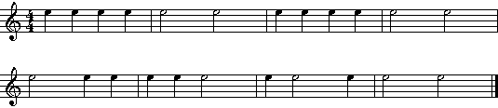  “ Who can tell me what kind of notes we played?”  “How many beats does a quarter note get? Half note?”  “Does anyone remember what a measure is?”  “How many beats were in the measures we played?” | 5-7 min.
B. Learning Activities: (What learning experiences and instruction will enable students to achieve the desired results – have more learning activities than you need)  1. Explain the concept of eighth notes to the class  “So today we are going to talk about eighth notes”  “If a quarter note gets one beat, and I told you that an eighth notes gets half of that, how many beats does an eighth note get?”  “So when we play an eighth note we will use the syllable ‘Ti-Ti’.”  “Lets try some eighth note patterns”  - Clap eighth notes patterns in 4/4 time using “Ti-Ti’ for eighth notes and “Ta” for quarter notes  “Alright so now this time I am going to clap and use syllables for the rhythm, and I want you to clap and say the syllables back. We are going to say “ti-ti” for eighth notes, and “ta” for quarter notes.  Ex)  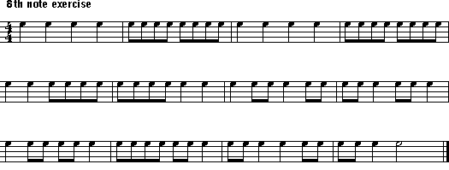  2. Teach the song “ Rain, Rain, Go Away” by rote  “ Ok guys, so now were going to learn a song and talk a bit about it afterwards”  “This is a song you might have heard before”. I want you guys to repeat after me when I point to you.”  (Take every 2 measures and progress to longer durations)  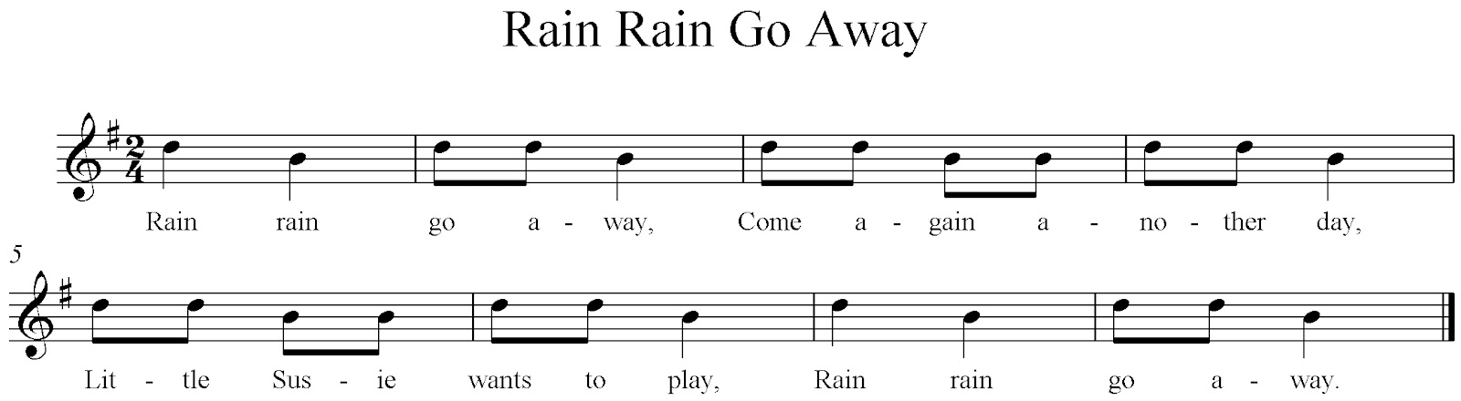  “ Now lets sing the whole song, but I want everyone to tap each beat on their lap this time.”  3. Write the song “Rain, Rain, Go Away” on the board  - Have 3 students take turns coming up to the board to circle 2 quarter note rhythms each in the song ”  “ So do we remember what a quarter note looks like?”  “It looks like this correct?” (Draw ♩)  “ Who can come up to circle two quarter notes for me?” (Do for 3 students)  - Show what an eighth note looks like, and have 3 other students come to board and circle one eighth note rhythm each  “ So we know what a quarter note rhythm looks like, but how do we know what a eighth note rhythm looks like?”  (Write each beat as a number under the first measure)  “ We are in 2/4 time, so how many beats does a measure get?”  “How many beats does a quarter note get again? What about an eighth?”  “ So we can see that every beat has one quarter note, which means that every beat can have two eighth notes.”  “Think about it when we are saying our syllables. ‘Ta’ or♩ =♩ and  ‘Ti-Ti’ or ♫=♩  “Who can come up and circle just one eighth note rhythm for me?”  (Repeat for 3 students)  4. Have students drum to “Rain, Rain” and sit at their seats  “So now I want everyone to grab a drum and sit at your seats.”  - Have students sing the song the whole way through one more time tapping each beat on their lap  “Lets sing this song again all the way through. Make sure to tap each beat on your lap.”  - Have students clap and say syllables to the rhythm only of “Rain, Rain”, and write the syllables over the rhythms on the board for them  “ Now this time we are going to say the correct syllables and only clap the rhythms.”  - Have students say syllables, but this time perform the rhythms on the drums  “Now this time we are going to just perform the rhythms on the drums. Say the syllables as you play.”  - Have students perform the rhythm on the drums while singing the song  “Now lets see if you guys can drum the rhythms and sing the song too.”  5. Gather students into even groups to create mnemonics for the first 4 measures of the song  - Demonstrate how to create a rhythm mnemonic based on a theme of choice  “So now I want you and your group to come up with some words that go with the rhythms of the first measure in this song”.  “The theme for coming up with these words can be about a type of weather, colors, or a season!”  “I’ll show you an example. Lets say my theme is about the fall. For a quarter note rhythm, I need a one-syllable word. And for an eighth note rhythm, I need a two- syllable word.  “I’ll use the word “leaves” for quarter note rhythms, and I’ll use the word “Crun-chy” for eighth.  (Demonstrate what this would sound like for the first four measures of the song, while playing the rhythms on the drum)  - Have students work in their groups to create a mnemonic for the first four measures of the song  “ So as a group, you guys are going to pick a theme and come up with 2 words to perform with the rhythms for the first 4 measures of the song like I just did. I will be coming around to each group.”  - Have assigned groups perform their mnemonics and rhythms on the drums one at a time  “Ok, so when I call your group, I want you guys to perform the words you made to your rhythms using your voices and the drums like I did before!” | 1. 5-7 min  2. 5-7 min  3. 5-7 min.  4. 5-7 min  5. 8-10 min.
C. Assessment: (What evidence will show that the students understand? Describe the assessment used – formal and informal assessments based on learning objectives)

Informal Assessment for performing in Activity 5:

- When students are placed in their even groups, individuals will be assessed based on how successful they were creating and performing their mnemonics, and how accurately they were able to distinguish quarter and eighth notes based on their choice of mnemonics and performance of rhythms.

- The assessment will be recorded with a chart of each student in each group. Students will receive a check next to their name in the grid if they meet the standard requirements, or a slash if they do not.

D. Closing/Wrap-up: (This is a recap of the key learning of the day to check for understanding. Could be a ticket to leave as individuals or group answers)  - Have the class use the drums to do an activity where they listen and only play back the teachers rhythms that have eighth notes  “Alright so before we go, I have a challenge for you guys. It’s kind of like Simon says. I am going to play you a rhythm, and if you hear an eighth note pattern in the rhythm I play, I want you to play it back. If you don’t, don’t play at all.”  (Mix the rhythms used in Brief opening and Activity 1)  - After the activity is declared over by the teacher, when students hear the next quarter note rhythm, they put the drums away silently. Afterwards, they listen for the next eighth note rhythm to line up at the door quietly. | 5-7 min.
E. Assignment: Students will be asked and encouraged to listen or create sounds with 8th note rhythms. Examples may be listening to a bird chirp outside, or listening to someone tap on a table. Students may be asked to share their experiences for the next class. | 40 min.

7. Accommodations: (a. Special Needs, b. ELL etc. )

A student with ADHD has difficulty paying attention when the teacher teaches a new concept by lecture. To accommodate this student, they will be provided with a visual guide as the lecture goes along for activities 1 and 2. That way they will be able to be able to focus and see how the visual goes along with the lesson when the lecture is going on.

8. Teacher Reflection/Self-Evaluation: (a. Reflect on the process and include student responses b. Rethink & Revise - what could you have done differently to improve the outcome of this lesson)

I felt that the activities in this lesson were engaging and productive for student’s knowledge of eighth note rhythms. There were many points in the lesson that I felt went well such as when students were participating and engaging in creating their rhythm mnemonics, as well as when they were able to play their drums while singing the new song they learned, “Rain, Rain Go Away”. These activities showed that students were engaged and learning the material through creative and active ways, which meant they understood the material at they’re own level and pace. I also felt that there were some points in the lesson such as the beginning clapping and patting activity, and learning eighth notes activity that did not go as well as they could of. Students seemed to be confused and unfocused during these points due to the fact that there was too much information thrown at them without any special activity to support the purpose. Next time, I would plan and create some more engaging activities for the students during these parts of the lesson. That way they could learn and understand the material in an occupying and entertaining way.

9. National Standards: (Creating, Performing, Responding)

Creating:
Imagine
MU:Cr1.1.3a Improvise rhythmic and melodic ideas, and describe connection to specific purpose and context (such as personal and social).
Plan and make
MU:Cr2.1.3a Demonstrate selected musical ideas for a simple improvisation or composition to express intent, and describe connection to a specific purpose and context.

Evaluate & Refine

MU:Cr3.1.3a Evaluate, refine, and document revisions to personal musical ideas, applying teacher-provided and collaboratively- developed criteria and feedback.
Present
MU:Cr3.2.3a Present the final version of personal created music to others, and describe connection to expressive intent.
Performing:

Select

MU:Pr4.1.3a Demonstrate and explain how the selection of music to perform is influenced by personal interest, knowledge, purpose, and context.
Analyze
MU:Pr4.2.3b When analyzing selected music, read and perform rhythmic patterns and melodic phrases using iconic and standard notation.
Rehearse, Refine, Evaluate
MU:Pr5.1.3a - Apply teacher- provided and collaboratively- developed criteria and feedback to evaluate accuracy of ensemble performances.
MU:Pr5.1.3b Rehearse to refine technical accuracy, expressive qualities, and identified performance challenges.
Responding:
Select
MU:Re7.1.3a Demonstrate and describe how selected music connects to and is influenced by specific interests, experiences, or purposes.
Evaluate
MU:Re9.1.3a Evaluate musical works and performances, applying established criteria, and describe appropriateness to the context.
Connecting
Connect #10
MU:Cr2.1.3a Demonstrate selected musical ideas for a simple improvisation or composition to express intent, and describe connection to a specific purpose and context.
MU:Cr3.2.3a Present the final version of created music for others, and describe connection to expressive intent.
10. State Standards: (Singing, Reading & Notation, Playing Instruments, Improvisation & Composition, Critical Response, Purposes & meaning in the arts, Rose of artists in communities, Concepts of style, stylistic influence & stylistic change, Inventions technologies & the arts, Interdisciplinary connections)

Singing
- 1.3 Sing from memory a variety of songs representing genres and styles from diverse cultures and historical periods
- 1.3 Sing from memory a variety of songs representing genres and styles from diverse cultures and historical periods
Reading and Notation
- 2.1 Demonstrate and respond to: the beat, division of the beat, meter (2/4, 3/4, 4/4), and rhythmic notation, including half, quarter, eighth, and sixteenth notes and rests
- 2.2 Use a system (syllables, numbers, or letters) to read and sing at sight simple pitch notation in the treble clef
- 2.4 Use standard symbols to notate meter, rhythm, pitch, and dynamics in simple patterns performed by the teacher
Playing Instruments
- 3.3 Play from memory and written notation a varied repertoire representing genres and styles from diverse cultures and historical periods
- 3.4 Echo and perform easy rhythmic, melodic, and chordal patterns accurately and independently on rhythmic, melodic, and harmonic classroom instruments
- 3.5 Perform in groups, blending instrumental timbres, matching dynamic levels, and responding to the cues of a conductor
Improvisation & Composition
- 4.1 Improvise “answers” in the same style to given rhythmic and melodic phrases
Critical Response
- 5.1 Perceive, describe, and respond to basic elements of music, including beat, tempo, rhythm, meter, pitch, melody, texture, dynamics, harmony, and form
- 5.3 Use appropriate terminology in describing music, music notation, music instruments and voices, and music performances
- 5.6 Describe and demonstrate audience skills of listening attentively and responding appropriately in classroom, rehearsal, and performance settings

